**DAILY ONLINE ACTIVITIES SUMMARY**

|  |  |  |  |  |  |  |  |  |
| --- | --- | --- | --- | --- | --- | --- | --- | --- |
| **Date:** | **26/07/2020** | | | | | **Name:** | **NAIPUNYA VINOD NAIK** | |
| **Sem & Sec** | **IV SEM & A SECTION** | | | | | **USN:** | **4AL18CS050** | |
| **Online Test Summary** | | | | | | | | |
| **Subject** | | **NO INTERNALS CONDUCTED** | | | | | | |
| **Max. Marks** | | **30** | | **Score** | | | **-------------------** | |
| **Certification Course Summary** | | | | | | | | |
| **Course** | **1)** NMAP SCANNING CYBER SECURITY COURSE  **2)** FUNDAMENTAL DATA ANALYSIS AND VISUALIZATION TOOLS IN PYTHON  3) AN INTRODUCTION TO FORTIGATE WEB FILTER  4) WEBINAR ON SALESFORCE JOB READY PROGRAM | | | | | | | |
| **Certificate Provider** | | | **1) UDEMY**  **2) UDEMY**  **3) UDEMY**  **4) UDEMY** | | **Duration** | | | **1) 38MIN**  **2) 1 HR**  **3) 1 HR**  **4) 1 HR** |
| **Coding Challenges** | | | | | | | | |
| **Problem Statement: Class vs Instance Problem Hackerank** | | | | | | | | |
| **Status:-EXECUTED** | | | | | | | | |
| **Uploaded the report in Github** | | | | | **YES** | | | |
| **If yes Repository name** | | | | | <https://github.com/naipunya-naik/Online-Coding-platform-coding/blob/master/Hackerrank04_Class%20vs%20Instance_26-07-2020.cpp> | | | |
| **Uploaded the report in slack** | | | | | **YES** | | | |

Online Test Details: (Attach the snapshot and briefly write the report for the same).

NO INTERNALS CONDUCTED

Certification Course Details: (Attach the snapshot and briefly write the report for the same).

CERTIFICATION COURSE NAME:- NMAP SCANNING CYBER SECURITY COURSE

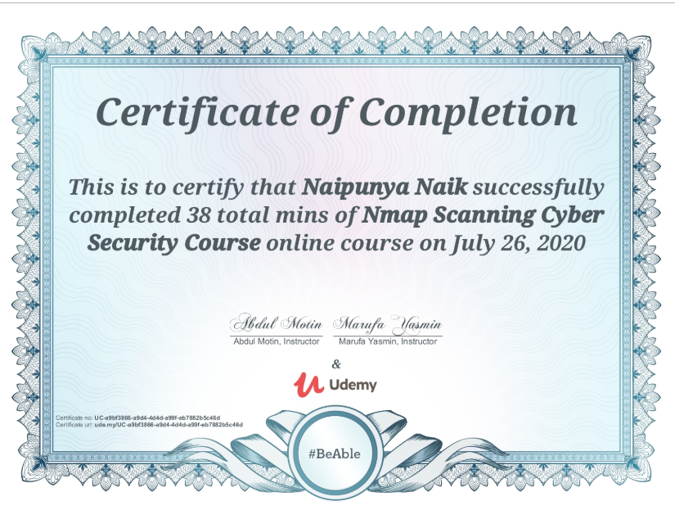

CERTIFICATION COURSE NAME:- FUNDAMENTAL DATA ANALYSIS AND VISUALIZATION TOOLS IN PYTHON

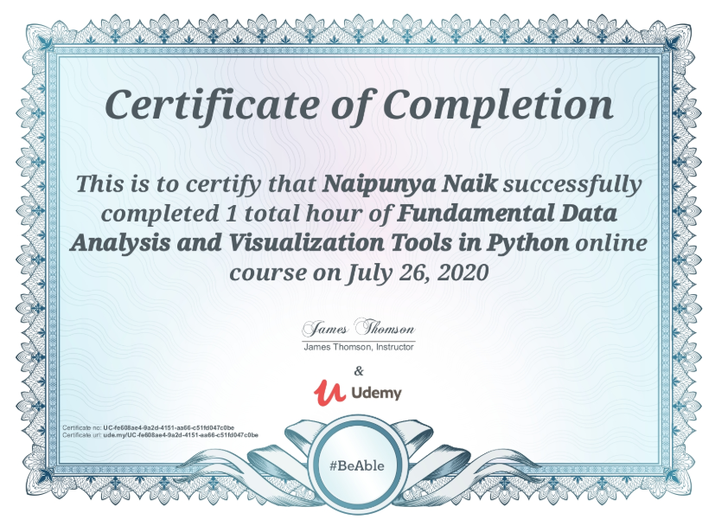

CERTIFICATION COURSE NAME:- AN INTRODUCTION TO FORTIGATE WEB FILTER

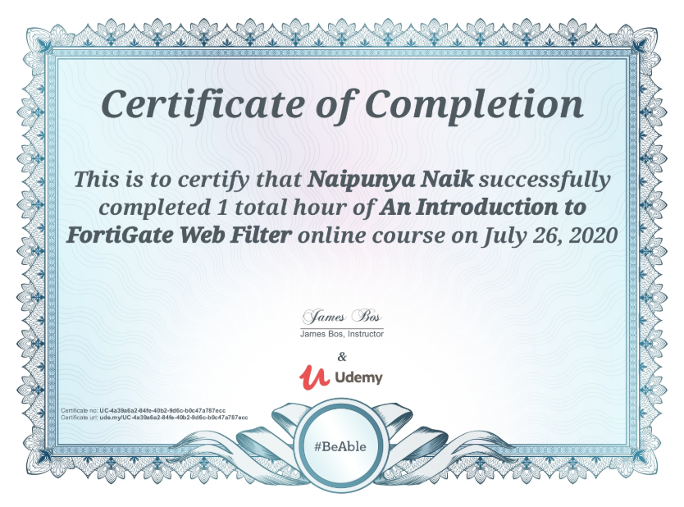

4) WEBINAR ON SALESFORCE- JOB READY PROGRAM

* DURATION:- 1 HR
* FROM 11.00 AM TO 12.00 PM

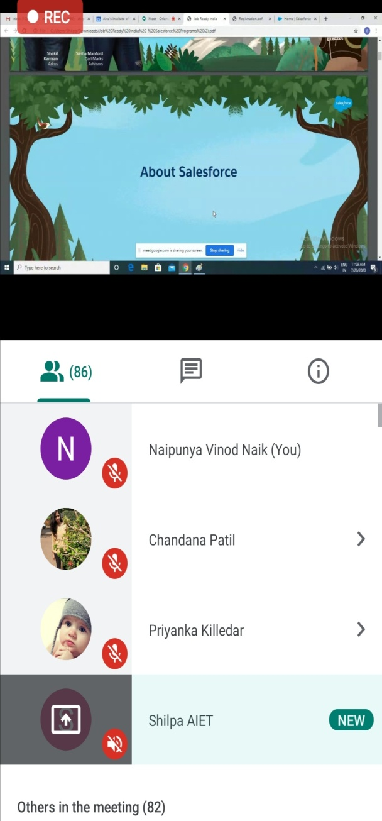 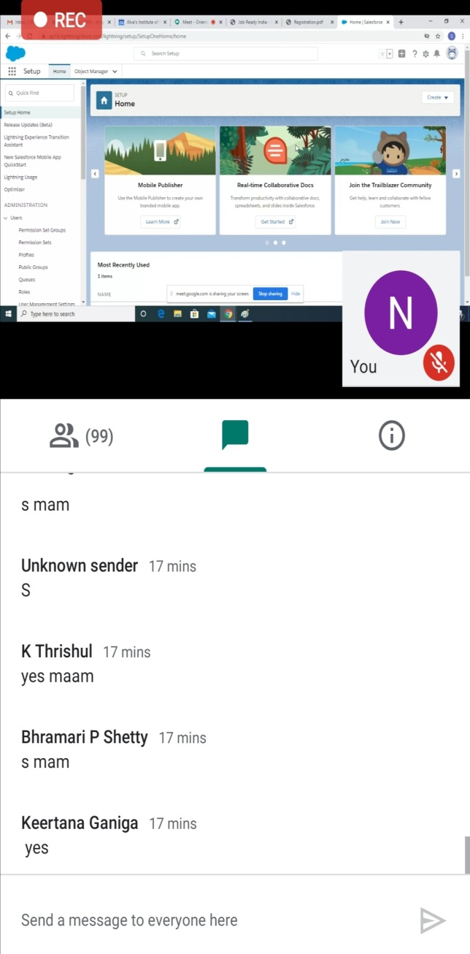

Coding Challenges Details: (Attach the snapshot and briefly write the report for the same).

PROBLEM STATEMENT:-Write a *Person* class with an instance variable, , and a constructor that takes an integer, , as a parameter. The constructor must assign  to  after confirming the argument passed as  is not negative; if a negative argument is passed as , the constructor should set  to  and print Age is not valid, setting age to 0.. In addition, you must write the following instance methods:

1. *yearPasses()* should increase the  instance variable by .
2. *amIOld()* should perform the following conditional actions:
   * If , print You are young..
   * If  and , print You are a teenager..
   * Otherwise, print You are old..

To help you learn by example and complete this challenge, much of the code is provided for you, but you'll be writing everything in the future. The code that creates each instance of your *Person* class is in the *main* method. Don't worry if you don't understand it all quite yet!

**Note:** Do not remove or alter the stub code in the editor.

**Input Format**

Input is handled for you by the stub code in the editor.

The first line contains an integer,  (the number of test cases), and the  subsequent lines each contain an integer denoting the  of a Person instance.

**Constraints**

**Output Format**

Complete the method definitions provided in the editor so they meet the specifications outlined above; the code to test your work is already in the editor. If your methods are implemented correctly, each test case will print  or  lines (depending on whether or not a valid  was passed to the constructor).

**Sample Input**

4

-1

10

16

18

I ATTEMPTED THIS QUESTION AND PASSED TWO TEST CASES.

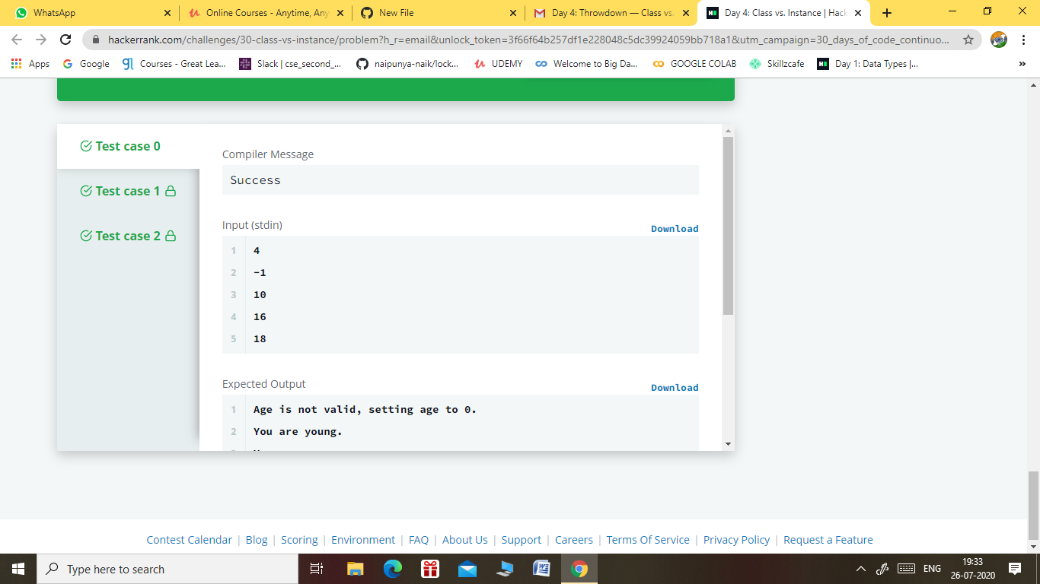

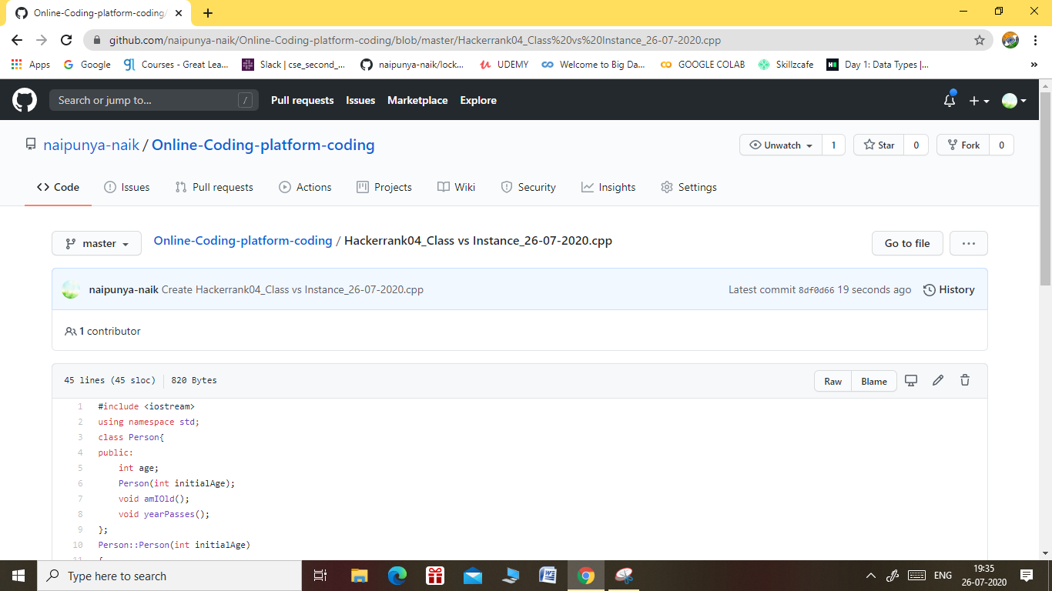

GITHUB REPOSITORY LINK:-

<https://github.com/naipunya-naik/Online-Coding-platform-coding/blob/master/Hackerrank04_Class%20vs%20Instance_26-07-2020.cpp>